**Output with explanations:**

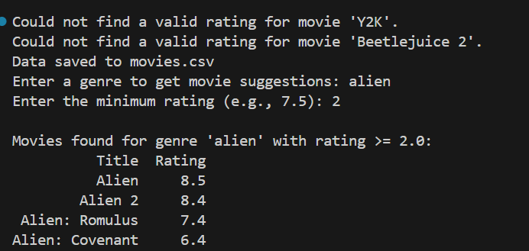

-- The Movie Recommendation bot provides output based on the user's selection. For instance, if the user is interested in a specific keyword like **'alien'** the bot will show all movies related to that keyword along with their ratings. If the user specifies a rating threshold, such as 2 stars, they will receive recommendations for movies with ratings greater than 2 stars.

-- For the movies 'Y2K' and 'Beetlejuice 2,' no ratings are available on the IMDb site, so the terminal displays a message saying it couldn't find a valid rating for these two movies.

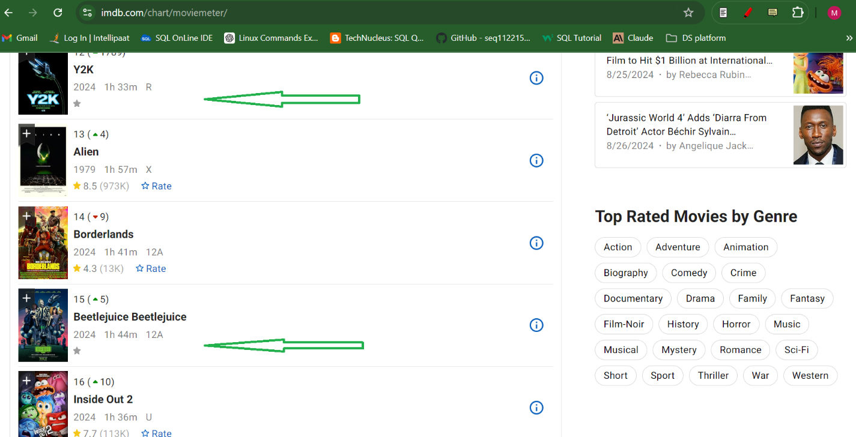

**Web scrapping for movie title and Rating:**

